REGIONAL CADET SUPPORT UNIT

(ATLANTIC)

JOINING INSTRUCTIONS

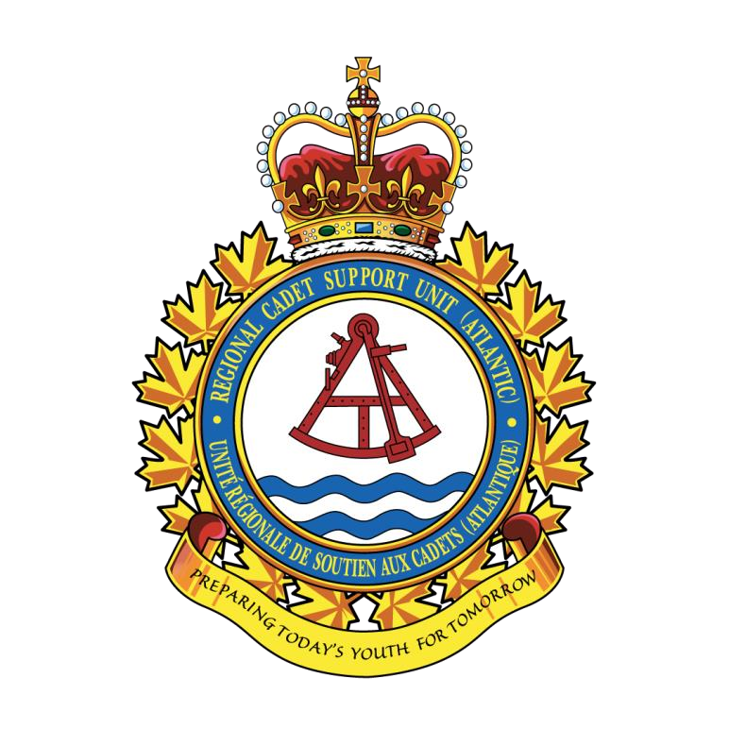

CADET LEVEL 1 EXPEDITION

NEW BRUNSWICK

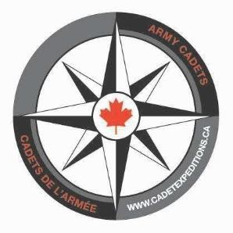

# INTRODUCTION

1. Cadets from across Atlantic Region will attend Cadet Level 1 Expedition Training Weekends throughout the Spring sessions. Cadet Expedition Site (CES) training has been designed to provide the Cadet with the opportunity to develop expedition skills in a structured environment under the supervision and instruction of highly qualified staff. The CES will approach training through an experiential approach, which will allow the cadet to develop skills in mountain biking, canoeing and hiking through direct experience at a personal level.

1. The purpose of these joining instructions is to provide the cadet and their parent(s)/guardian(s) with the information necessary for them to prepare for and participate in the training weekend.

# GENERAL

1. CES’s will conduct a review with cadets on the following knowledge and skills; campsite set-up, types of expedition equipment, navigation, packing expedition equipment, following daily expedition routine, and assessments.

1. A sample weekend training schedule is located at Annex C. Note that the schedule provided is just a sample, and our CES’s will adjust plans to suit weather, and other environmental changes during training.

1. With the proper training and preventative measures, expedition training can be a safe, fun, and meaningful experience. The expedition weekend will provide this safe, fun, and meaningful experience to cadets all while enabling them to enjoy the outdoors.

1. Cadets will be sleeping in tents for both nights and provided training in up to two of the following activities:

* 1. **trekking** a distance of up to 10 km (cadets will be introduced to and review/elaborate onprevious trekking training. They will work and train with trekking equipment; packs, boots, trekking poles, stoves, water filtration, tents. They will also train in navigation and outdoor leadership); and/or

* 1. **flat water canoeing** a distance of up to 10 km (cadets will be introduced to andreview/elaborate on previous canoe training. They will work and train with canoe equipment; packing, loading, unloading, launching/landing. They will also train in navigation and outdoor leadership) this activity will be condition permissive; and/or

* 1. **mountain biking** (trail riding) a distance of up to 30-40 km (cadets will be introduced toand review/elaborate on previous mountain bike training. They will work and train with mountain bike equipment; helmets, gloves, repair equipment, mountain biking techniques, balance, braking, shifting, ascending, descending. They will also train in navigation and outdoor leadership);

1. As with any training in a wilderness environment there is a degree of inherent risk associated with your child’s/ward’s participation. That being said, training injuries can and do occur. To further mitigate this eventuality, we employ staff, in supervisory positions on the course, with the Wilderness First Aid Course. In addition, we have developed a detailed Emergency Response Plan which allows us to safely evacuate injured cadets from training sites to professional medical care in a timely fashion. The potential hazards associated with this training include, but are not limited to:

|  |  |
| --- | --- |
| Fall from height | Cold/heat related injuries |
| Falling objects | Drowning |
| Driving accident | Lost participant |
| Animal encounter | Food/Water Loss or Contamination |
| Extreme Weather | Burns |
| Athletic injuries (sprains & strains) | Equipment failure |
| Trips, Falls, Collisions (including cuts, head & spinal  injury) | Allergic reactions to plants, insects, or unknown food allergies |

1/5

# PRE TRAINING

8. Prior to attending the training weekend each cadet should receive a briefing from their corps staff that reviews:

1. selection of clothing, footwear and equipment,

1. the CESs joining instructions and training schedule.

# OBJECTIVES

9. Specific objectives of expedition training are to:

1. promote a feeling of fun and satisfaction of being a part of an exciting and adventurous activity;

1. increase personal development; including self-confidence, self-discipline, self-esteem, self-worth and self-satisfaction;

1. develop outdoor abilities, techniques, skills and prepare for outdoor leadership development;

1. promote improvement in personal fitness conditioning and encourage healthy lifestyle choices;

1. promote an increased awareness and concern for the natural environment; and

1. develop an awareness of the skills and knowledge necessary to cope safely in adventure training activities.

# ASSESSMENT OF PARTICIPANTS

1. All cadets participating in the training weekend will be formally assessed. Assessment results will be entered into Fortress and forwarded to the respective cadets’ corps. Assessments will be used to determine if a cadet has the basic understanding of expedition skills required to advance to a leadership focused expedition. Cadets that do not achieve the standard may return to the NB CES for further development at the same level or receive this training at their home unit.

1. All cadets will receive an individual de-briefing by their assigned Team Instructor to discuss their performance over the course of the weekend.

# CONSENT TO PARTICIPATE

12. All cadets must sign a copy of the Offer of Participation Courses, Positions and Activities. This form should be printed off by the corps Admin O and signed by the cadet’s parent(s)/guardian(s), and kept at the corps.

# TRANSPORTATION/MOVEMENTS

1. All transportation to and from training site is provided by the DND. Corps will receive transport itineraries from the regional movements staff either via FortressV2 or Email through the unit

Commanding Officer. A cadet corps officer will meet all cadets at the assigned pick-up / drop off point.

An escort officer will travel with the cadets from the pick-up point to the CES and back. Parental drop off may be required for corps in close proximity (less than 1 hour).

2/5

1. For cadets who are taking commercial transportation to the CES they will be met by an officer at the start and end point of their journey.

1. **Cadets are NOT required to travel in their cadet uniform**.

1. All cadet transportation information will be sent to the corps CO not later than one week prior the expedition training weekend.

1. There may be a requirement for parent(s)/guardian(s) to transport cadets to and from a specified pick-up / drop-off location.

# ACCOMODATIONS AND MEALS

1. All accommodations and meals during the expedition will be pre-arranged and DND will bear the cost.

1. Cadets will be sleeping overnight in civilian pattern expedition style tents. Sleeping bags and air mattresses are provided. Cadets allergic to down should notify their Commanding Officer (CO) who will notify the CES OIC to make necessary arrangements for a synthetic sleeping bag.

1. During the training weekend cadets will be fed Individual Meal Packages (IMPs) or Meals Ready to Eat (MREs).

1. Cadets who are vegetarians, have food allergies or have special diet requirements should inform their corps CO who will then inform the CES EL who will make alternate arrangements.

# DRESS

1. Dress during training shall be suitable civilian clothing based on both current and forecasted weather conditions, air temperatures, insulating properties of clothing worn, and the ability to allow the wearer to remain dry.

1. Annex A of these JIs provides a complete list of clothing that should be brought to the CES. If a cadet does not have access to all of the items listed in Annex A, they should inform their corps CO who will then inform the CES EL so that the items can be procured.

1. Annex A also provides a detailed list of clothing and equipment items that will be issued to each cadet while at the CES.

# MEDICAL / DENTAL / HEALTH

1. All cadets participating in the training weekend must have a current Basic Health Questionnaire and Detailed Health Questionnaire (if required). Medical status must also be up to date without any medical restrictions that would prevent the cadet from participating in training.

1. If a cadet has a temporary medical issue, such as a sprained wrist or knee, broken arm, etc. they must notify their corps CO who must get in touch with the Expd Trg O to ensure they are capable of participating in training. **Any cadet with a “30 minute to medical services limitation” and/or an “UNFIT CTC/LHQ activities pending a resolution of a current medical condition” on their respective FortressV2 file shall be registered under the Urban Expeditions only. Please contact the CES EL to register these cadets for the Urban Expedition.**

1. **Facilities / Services.** Medical and dental emergencies will be handled through a combination ofon the spot first aid and the local 911 emergency systems. During training, medical incidents will be handled using first aid and evacuation to a designated medical facility. More serious incidents will involve the services of Emergency Services.

3/5

1. **Prescription Medication**. Cadets taking prescription medication for an existing medicalcondition must bring a sufficient supply for the duration the training weekend. Medications must be in clearly labelled containers. Individuals allergic to bee and wasp stings must have an ANAKIT with them and carry it on their person at all times.

# EYE GLASSES / CONTACT LENSES

30. Either eyeglasses or contact lenses are suitable for expedition activities. Cadets wearing eyeglasses during the expedition must wear a safety strap.

# DISCIPLINE AND BEHAVIOUR

31. Cadets indulging in inappropriate behaviour, violation(s) of rules/regulations or disrupting the learning of others will be subject to disciplinary action including the possibility of Return to Unit (RTU).

# DRUGS, ALCOHOL AND TOBACCO

1. **Regulations**. The orders detailed in CATO 13-23 concerning drugs and alcohol will be applied toconduct of the training weekend. Cadets who possess or use drugs, prohibited substances or drug related material will be reported to local civilian police. The use of alcohol by cadets will result in an immediate return to unit (RTU).

1. **Tobacco**. Smoking by cadets will not be permitted.

# EMERGENCY CONTACT NUMBERS

1. The following is a list of emergency contact numbers:
   1. Capt Mandy Van Beek, Expedition Leader (EL) NB CES
      1. cell: 902-314-2424
      2. email: [amanda.vanbeek@cadets.gc.ca](mailto:amanda.vanbeek@cadets.gc.ca)

* 1. Capt Scott Nixon, Regional Trg O(Expedition):

* + 1. office:. 902-720-2143

* Communications regarding the expedition are to be directed to the Cadet Expedition Site EL

1. As training may be conducted in remote locations, cadets may not have access to a telephone. However, there will be both cellular and/or satellite phones for emergency communication purposes.

4/5

Annex A – Clothing and Equipment List

Annex B – Packing Tips

Annex C – Sample Weekend Training Schedule

Annex A

Joining Instructions – Cadet Expedition Sites

# CLOTHING AND EQUIPMENT LIST

1. The provision of all personal clothing and equipment items listed below is the responsibility of each cadet. **Prior to purchasing any outdoor related clothing and equipment cadets should contact their corps CO or the CES EL**.

1. Cadets are required to bring the following items in the “personal kit” column, issued kit will be provided for use during and returned at the end of the expedition:

|  |  |  |
| --- | --- | --- |
| Personal Kit | Issued Kit | Issued Group Kit |
| 4 x outer socks (wool, synthetic) | Expedition field pack | Tent |
| 4 x liner socks (not cotton) | Pack liner | Pocket knife |
| 3 x underwear | Compression sack(s) | Compass |
| 1 x long underwear/ base layer | Stuff sack(s) | Mountain Stove |
| 2 x t shirts | Sleeping bag | Safety Vest |
| 2 x long pants (no jeans) | Sleeping bag liner | Fuel bottle |
| 1 x sweater or hoodie/ insulating layer | Air mattress | Pot set |
| Duffle bag **(NO ROLLING SUITCASE)** | Headlamp | Waterproof match container |
| Pyjamas or sleepwear | Whistle | Matches |
| 1 x hat | Rain Gear (limited) | Jerry can |
| 1 x toque | Helmet (if applicable) | Fire extinguisher |
| 1 x pair gloves | Bike (if applicable) | First aid kit |
| 1 x pair sneakers | PFD (if applicable) | Backpacking tarp |
| 1 x hiking boots or combat boots | Paddle (if applicable) | GPS |
| Day Bag (Small backpack) |  | Naphtha |
| **1 x water bottle or hydration pack 1L** |  | Toilet paper |
| 1 x wrist watch |  | Glow sticks |
| Travel size soap or wipes |  | Re-sealable plastic bags |
| Travel size deodorant | S | Garbage bags |
| Travel size toothbrush and paste |  | Hand sanitizer |
| Comb/hair brush |  | Canoe equipment (if applicable) |
| Sunglasses |  | Bike equipment (if applicable) |
| Coat (weather appropriate) |  | Foot powder |
| Healthy snacks (optional) |  |  |
| Flashlight/ headlamp |  |  |
| Sunblock |  |  |
| Lip balm |  |  |
| Notebook and pencil |  |  |

1. Cadets who do not have an item should notify their corps CO ASAP, who will then contact the CES CO, who will make arrangements to procure the equipment for the cadet. Attendance should not be determined by lack of personal kit items.

1. No radios, MP3 players, cellular phones, video games or similar electronic devices will be permitted during training hours.
2. CESs have a limited supply of large, x-large, and xx-large sizes of rain gear and size 12 and higher in hiking boots. If a cadet requires these sizes please contact the CES CO so that arrangements can be made.
3. In order to avoid blisters, cadets must have properly fitting footwear that comfortably fits a liner sock that is not cotton (material that wicks moisture such as bamboo or synthetic blend) and an outer sock (such as wool). Keep your feet dry (there will be foot powder in the team kit but if cadets would like to bring their own, they may do so). If a cadet chooses to bring their own hiking boots, they must be waterproof, combat boots will work if they were issued by the corps but not recommended for hiking. Sneakers are required for biking. It is highly recommended that more than one pair of footwear is brought if available for downtime and in case 1 pair gets wet
4. If you bring your own snacks, such as trail mix, please inform your team leader upon arrival. These can not be kept in the tent and your team leader will store them for you until the morning.

1. **The following items will NOT be brought to the CES training site by any participants:**

|  |
| --- |
| **Forbidden items:** |
| Personal climbing equipment |
| Personal canoeing/hiking/mountain biking equipment |
| Junk food of any sort |
| Inapp ropriate books or magazines |
| Non -prescription drugs, alcohol, or other controlled substances |
| Ammunition, firearms (or any other weapon) of any kind |

Joining Instructions – Cadet Expedition Sites

# PACKING TIPS

1. Before departure, double check all belongings and documents. Use this list to ensure that nothing has been forgotten.

|  |  |
| --- | --- |
| **INSTRUCTION** | **CHECK** |
| Is your personal kit complete and marked? |  |
| Do you have your prescription medication (enough to last the weekend)? |  |
| Do you have a floating security strap for your glasses? |  |
| Do you have your MEDIC ALERT bracelet or necklace, if applicable? |  |
| Do you have your health insurance card / number? |  |
| Do you have your signed copy ‘Offer of Participation’? |  |
| Do you know exactly how you are travelling? If not, contact your CO. |  |
| Did you care for your feet, trim your toe nails? |  |
| Did you check and re-check your required personal equipment? |  |

Joining Instructions – Cadet Expedition Sites

# SAMPLE WEEKEND TRAINING SCHEDULE

1. Below is a sample schedule of a Cadet Expedition Site Training Weekend.

|  |  |  |
| --- | --- | --- |
| **FRIDAY** |  |  |
| **Timings** | **Tasks/Activity** | **Remarks** |
|  | Collect all applicable paperwork. | Place cadets in teams of varied skill levels. |
|  | Initial interview and goal setting | Staff to interview cadets and review expectations and goals |
|  | Issue all personal expedition equipment | Cadet Expedition Site staff. |
|  | Set up campsite | Cadet Expedition Site staff to rotate to ensure that cadets know how to set up tents, organize equipment, etc. |
|  | Initial briefing/break cadets into teams | To include: activities, expectations, safety, timings, dress, meals, rules, etc. Cadets will be introduced to their staff. |
| **SATURDAY** |  |  |
| **Timings** | **Tasks/Activity** | **Remarks** |
| 0600 | Reveille/Ablutions | Cadets will pack all personal equipment prior to eating breakfast. Cadet Expedition Site staff to model and supervise daily routine activities. |
| 0630 | Breakfast | Cadet Expedition Site staff to model and supervise set-up of eating area, garbage collection, clean up, etc. |
| 0730 | Campsite tear down | Under direction of TL each team will tear down all components of the campsite, organize personal and group equipment for transport to a new campsite. |
| 0800 | Classes | Classes on navigation, equipment use and maintenance, safety and risk assessment, camp routine |
| 1200 – 1300 | Lunch | Lunch will occur at a designated point along the practical expedition route.  TI will use time during lunch to instruct EO M326.06 (Follow Daily Routine). |
| 1300-1630 | Classes | Introduction to mode of travel (MOT) |
| 1630 | Campsite set up | Teams will set up their campsites. |
| 1730 | Supper |  |
| 2000 | Evening Activities |  |
| 2200 | Lights Out |  |
| **SUNDAY** |  |  |
| **Timings** | **Tasks/Activity** | **Remarks** |
| 0600 | Reveille/Breakfast/Tear down campsite | Teams will be required to complete daily routine activities. |
| 0800 | MOT 1 |  |
| 1200- 1300 | Lunch | Lunch will occur at a designated point along the practical expedition route. |
| 1300-1500 | MOT 2 | Upon arrival at end point teams will complete the de-kitting process under the direction of the Log O. |
| 1500-1530 | Debrief | All cadets will be required to: fill out an Cadet Expedition Site activity critique and complete a journal entry about their experiences during the weekend. |
| 1600 | Depart |  |